**Task 2: Call Centre Trends** - Visualising customer and agent behaviour.

Task Overview

**What you'll learn**

* The importance of upskilling in the digital age and its role in the workplace.
* The concept of becoming a "Digital Accelerator" and the skills associated with it.
* How to create a Power BI dashboard for visualizing key performance indicators (KPIs) and metrics.

**What you'll do**

* Create a dashboard in Power BI for visualizing relevant KPIs and metrics in the dataset provided.
* Utilize the resources provided, including podcasts and articles, to enhance your understanding of data visualization and upskilling.
* Respond to the client's request by providing a well-designed Power BI dashboard reflecting the requested KPIs.

Here is your task

It’s omnipresent: telecom marketing. Better price here. Better service there. Best for small businesses here. Best for young urbanites there. But what do customers really want? Our client, a big telecom company needs to know. This email just arrived for you:

Create a dashboard in Power BI for Claire that reflects all relevant Key Performance Indicators (KPIs) and metrics in the dataset. Get creative!

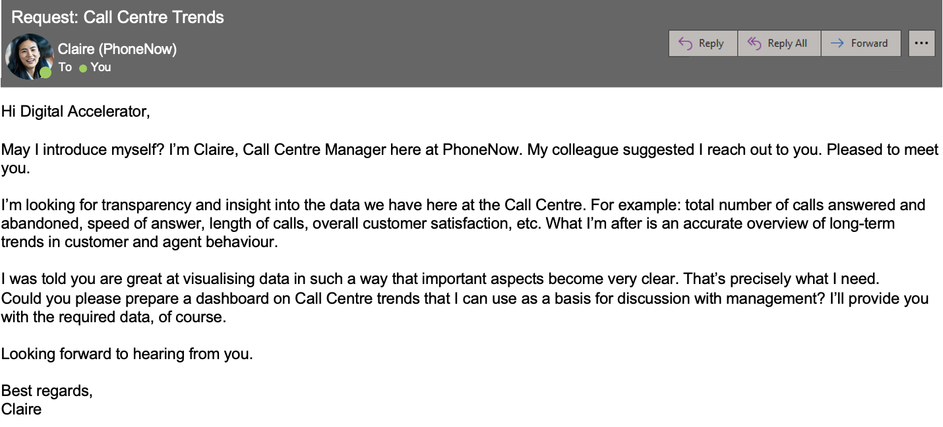

**Possible KPIs include (to get you started, but not limited to):**

* Overall customer satisfaction
* Overall calls answered/abandoned
* Calls by time
* Average speed of answer
* Agent’s performance quadrant -> average handle time (talk duration) vs calls answered

Do you want to learn more? Level up by listening to a portion (or all!) of our podcasts linked below and read our articles.

**Podcasts**

* [PwC's Tech While You Trek: Data Visualization](https://pwctechwhileyoutrek.buzzsprout.com/1150349/4885124-pwc-s-tech-while-you-trek-data-visualization)
* PwC's [Tech While You Trek: PwC's Digital Upskilling Journey](https://pwctechwhileyoutrek.buzzsprout.com/1150349/5001527-pwc-s-tech-while-you-trek-pwc-s-digital-upskilling-journey)

**Further information**

* [Transforming your workforce through upskilling](https://www.pwc.com/us/en/tech-effect/automation/workforce-upskilling-strategy.html)
* [Workforce of the Future](https://www.pwc.com/us/en/services/consulting/workforce-of-the-future/workforce-inside-podcasts/workforce-inside-upskilling.html)
* [Upskilling: Creating a secure future through digital skills](https://www.pwc.ch/en/insights/upskilling-creating-a-secure-future-through-digital-skills.html)
* [How we teach digital skills at PwC](https://hbr.org/2018/10/how-we-teach-digital-skills-at-pwc)